**Project 1: Image Hybridization**

Computer Vision CIE 552

Asmaa Shaban 201600780 – Dina Adel 201601463

**Introduction:**

In this mini-project, we have implemented a function my_imfilter that convolves a filter kernel to a given image. The function also pads the image in one of two ways: zero padding and reflection padding. Padding method is given to the function as an additional string input that is either ‘zero’ or ‘reflect’. We have also implemented a hybrid image generator that applies a low pass Gaussian filter to the images in the time domain using the my_imfilter function.

**Interesting implementation detail:**

1-replicating the kernel 3 more times in an additional axis for colored images:

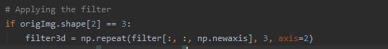

**2-** creating a color map of varying run time with different kernel sizes and image sizes:

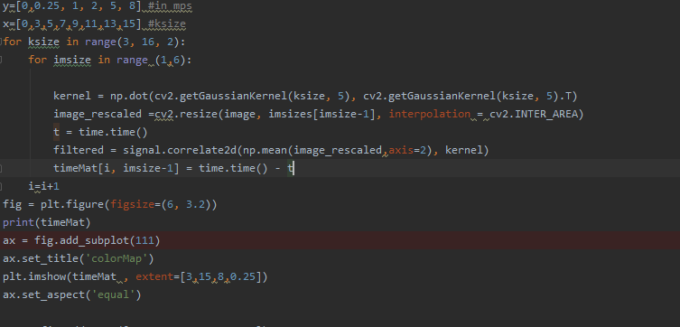

**Results:**

**Part 1: testing the convolution function:**

**1- image passed through an identity filter (unchanged):**

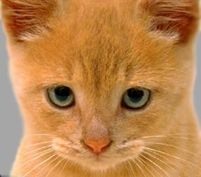

**2- Significantly blurred by CV2 generated Gaussian kernel :**

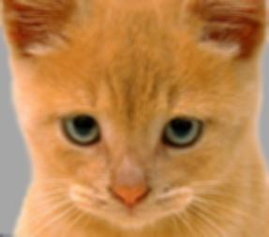

**3- a little bit blurred by a box filter:**

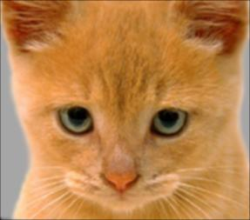

**4- High pass filter alternative (original- blurred)**

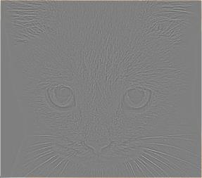

**5- Discrete laplacian HPF:**

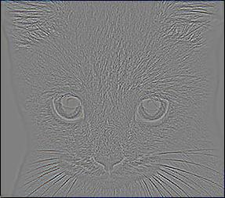

**6- Sobel operator:**

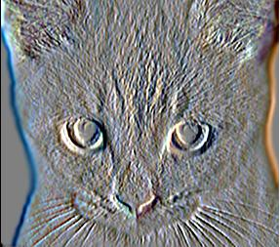

**Part 2: Testing the Hybridization images:**

**A- Marilyn Monroe and Einstein:**

**Parameters used: cutoff_frequency = 9 kernel_size = 9**

**1- Low frequency image:**

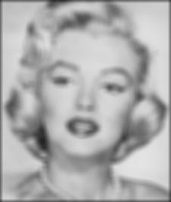

**2- High pass image:**

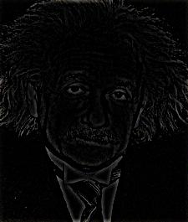

**3- Hybrid Image:**

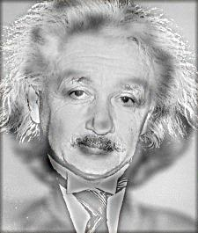

**4- Visualization:**

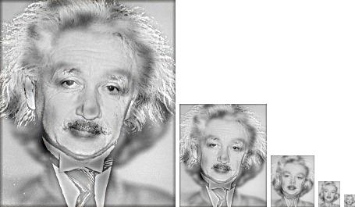

**B- Puppy and Kitten:**

**cutoff_frequency = 6 kernel_size = 23**

**1- Low pass image:**

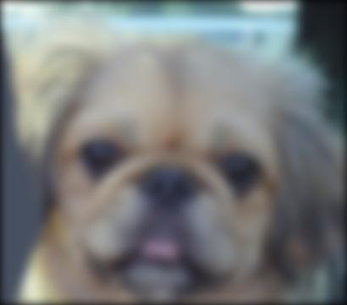

**2- High pass Image:**

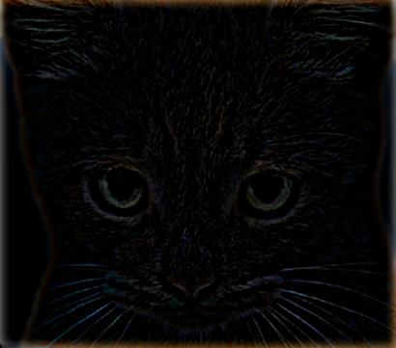

**3- Hybrid Image:**

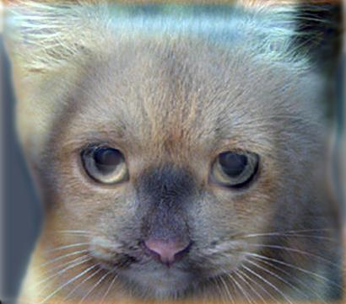

**4-Visualization:**

